**Michael Watkinson (B), Palak Patel (A)**

**IT 306 Project - Phase 2**

***PMV Event Ticketing***

**Project’s purpose and Business Requirements:**

As a IT Consultants, we have been contracted to design an event ticketing system to consolidate the ticket purchasing experience for stadiums and venues across the country. The purpose is to create a more streamlined, user friendly ticket purchasing process based on location, rather than genre or category, and integrate several other features. The system will allow its users to search by location for an event and select an event or event series from a list matching their location search criteria. The new ticketing system will also offer the purchasing of a parking pass when a ticket has been purchased. The event ticketing system should also allow for quick and easy refunds and viewing of purchased tickets for the systems users.

**Intended Users:**

The expected users of the PMV Event Ticketing System are individuals over the age of 18 who are interested in purchasing event/concert tickets. The users are also expected to be residents of the United States. The intended users should be credit card holders and should have their credits cards with them at the time of purchase to make the required payment of the ticket booking.

**Project Limitations:**

The system should allow intended user to purchase a ticket using the personal information in their user accounts. This system allows user to pick the event they want, the time and type of event, the location or venue of the event, and the level of the seating given in the options. This system allows user to also purchase a parking pass based upon availability. This system gives the user an option to cancel or refund their tickets up to two weeks before an event’s scheduled date. The user is allowed to purchase tickets for a single event per transaction. The application should calculate the price of the ticket based on user selected input.

**Palak Patel - Part A (Part1)**

**User Ability:**

PMV Event Ticketing System is useful for everyone who is interested in purchasing tickets for events like concerts or games. They will be able to create an account. They can enter information about the location like state or zip code and then browse through the stadiums listed. They can select the stadium of their choice and can view the events for that particular stadium. If they see an event they like, they can purchase the tickets based on the seating level, although, they cannot choose a particular seat. After the user is done paying, they can either go back and search for other events or exit out of the application. The user information is updated and the user can come back and cancel their tickets two weeks from the scheduled event date and get a refund.

The user will be provided with lots of information about the location and events at a particular stadium. The user will have enough ways to find the event they would like to attend like searching by the type of event.

The manager will be able to log into the application with their fixed credentials to look at the events, edit the stadiums, locations, dates, and event type. The manager can add any extra events or stadiums which will be added to the database. If the manager deletes anything, it will also be deleted from the database.

**Execution:**

Once the application has started running, the user will be able to login with their username and password or they are given an option to create a new account. When creating a new account, the users are required to give various details about themselves like name, address, email, username, and password. After successfully creating an account or logging in, the application requires them to enter state or zip code. The application will then present the user with the stadiums near by the given location. The user will be able to select the stadium of their choice and view the events scheduled for the next six months. If they want to go back to the list of stadiums, they can simply click the "Back" button. If the user wants to search by the type of event, for example concert or sports event, then they can use the drop down box to search by the event type. The user can select the event of their choice and will be presented with all the locations it is available at and their dates throughout the country.

After the user is done choosing a single event, the application asks the user for the number of tickets and level of seating they prefer. Then, the user will be asked to verify the order given the ticket and event details. If the user declines the order, they are taken back to enter the state or zip code. If they accept the order, the user are charged for the purchase and shown the confirmation ID on screen. The user will be able to cancel the tickets two weeks before the scheduled event date. The application then asks the user to enter state or zip code again to look for other events or they can log out from the application.

**Palak Patel - Part A (Part2)**

**User Interface: Expected Views of Input/Output**

When the application starts, login screen appears:

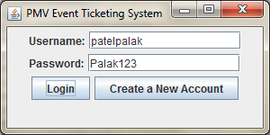

If the user is new to this application, they can create an account as follows:

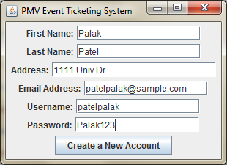

Once the user is logged in successfully, or created an account, following screen appears:

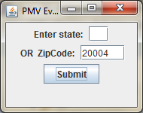

After entering the zip code, user is required to choose the type of event and the stadiums near by the given zip code:

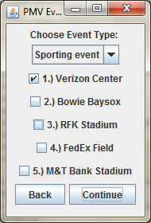

Once the user hits 'Continue', the application presents the events available at that location:

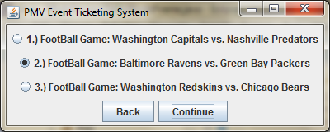

After selecting the event, the user is presented with the price and location of the event, and they can select the seating level and hit 'Continue':

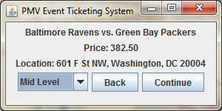

The user is asked for their credit card number at this point, as follows:

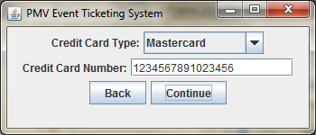

The user is given the option to go further with their purchase or decline it:

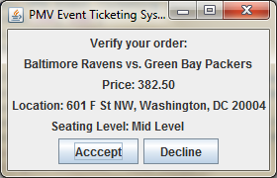

If the user accepts the order, they are charged for their purchase and given a confirmation ID:

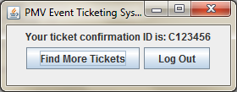

If the user declines the order, they are returned back to the following screen which asks for state or zipcode again:

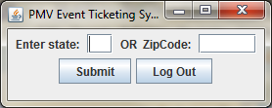

**Michael Watkinson - Part B (Part1)**

**Outline of Test Plan:**

**UI Items for Test Plan**

The user interface items that are required in the test plan are Login, Account Creation, Area Selection, Location Selection, Event Selection, Event Information, Confirmation, Payment, Refund, Admin, Create Admin, and Update screens. The Login screen should be the first screen that both public and administrator users are shown which prompts them to either provide their username and password or create a new account. The Account Creation screen allows a new user to create a new account by entering a username and password. On the Area Selection screen the public user will be prompted for either a state or zip code with which the program will search for any locations with events in the area provided by the user. The Location Selection screen displays the locations that meet the search criteria and allows the user to select a location to view available events. The Event Selection screen displays all upcoming events within the next six months for the location the user entered in the location selection screen and prompts the user to select a single event or an event type to narrow the results. The Event Information screen is displayed once the user has selected an event and it provides information about the event such as location, ticket price, seating, parking availability, time, and date. It also provides the option to purchase the ticket or return to the events list. The Confirmation screen displays a message to verify the order and prompts the user to either confirm the ticket purchase is correct or decline and be returned to the Event Selection Screen. The Payment screen prompts the user to enter their credit card number and billing information they wish to use to purchase the ticket. After the user purchases a ticket they receive a unique confirmation id. The Refund screen allows a user to enter their confirmation id to refund or cancel their ticket. A method is called to check if the event is more than two weeks away in order to validate the refund. The Admin screen displays the options for an admin to either create another admin account or update information about a location or event. The Create Admin screen prompts an admin to enter a username to be promoted to an administrator account. The Update screen allows an admin to select either an event or location for which to change the names, pricing information, or event series information.

**Required User Input and Files**

All users must initially input their username and password to gain access to the event ticketing system. If it is a new user then the user must enter a username, password, name, and email to create a new account. This information is then stored in a file named “publicUser.txt” along with their address, credit card info when buying a ticket and finally confirmation ids for purchased tickets. The user must enter a state or zip code, location, and event when prompted during the ticket selection process. This data is just used to find the user’s desired ticket during runtime and is not saved into a file. The administrator users can enter another username to promote that account to an admin or enter new information about events, event series, or locations. This updated information would then be used to modify their respective files, being one of “publicUser.txt”, “adminUser.txt”, “ticket.txt”, “eventInfo.txt”, “eventSeries.txt”. “location.txt”, or “parkingPass.txt.”

**Exceptions**

NullPointerException is a possible exception during the runtime of the program but every step will be taken through coding and error checking to ensure that it does not occur or interrupt with program functionality. Another possible exception is FileNotFoundException, which is always a possibility during reading from or writing to external text files due to improper file or path names or simply a missing file. All steps will be taken to ensure that correct path and file names are used to ensure that the program can function normally.